Less Testing = More Time for Better Teaching and Deeper Learning
Over-Testing does not improve the quality of a child’s education; instead it takes time from learning and narrows our curriculum. We must urge JCPS to drastically reduce the number and frequency of district mandated and required tests in order to allow our students and teachers to focus on what’s important: We want our students to spend more time on developing critical and creative thinking skills and the development of capacities and dispositions to help them thrive throughout life, and less on rote memorization. We want to give our educators more time to connect one-on-one with each student, especially those most in need of extra help.

Too Much Testing
- JCPS administers more than 320 diagnostic and proficiency tests to students each year, in addition to the more than 90 which are required by the state and federal government.
- An ever increasing number of parents and community members support rolling back testing requirements to increase learning time and quality for students.
- Nation-wide 77% of Americans believe that increased testing has either hurt or made little difference in improving schools.

Over-Testing Hurts Children
- Testing doesn’t close the achievement gap between affluent students and students who live in poverty: In spite of increased proficiency levels among students of all groups, and in spite of the huge number of tests required by the federal, state, and local JCPS administration, the achievement gap between affluent students and students who live in poverty in JCPS has actually grown.
- Too much testing strips away learning time: On average, JCPS teachers report that students lose between three and five weeks worth of valuable instructional time per year to mandated and required tests.
- Excessive testing narrows the curriculum: Some schools are reducing or eliminating electives in order increase time available in the schedule for reading and math. Students are losing opportunities to learn the arts, physical education, and vocational interests.
- Learning is supplanted by test taking: Learning opportunities in the core classes (reading, math, science, and social studies) may be narrowly focused on test preparation, limiting access to active and project-based learning opportunities that students may find more engaging. In addition, students who are enrolled in elective classes like art and music, are often pulled from those classes for additional testing and test preparation.
- Constant testing increases student misbehavior: In a recent survey on student discipline, more than 90% of JCPS teachers who responded indicated that they believe teaching to a test contributes to student misbehavior in class. Too much testing causes students to become disengaged and frustrated. When the focus is on testing instead of engaging learning experiences, students lose their love of learning and act out. Eventually they lose their love of learning, and school becomes a chore.
- A culture focused on testing and test prep prevents teachers from connecting one-on-one with students and increases student misbehavior: When the primary focus of class time is devoted to assessments, students have difficulty staying engaged, and teachers are not able to spend the time necessary to develop one-on-one relationships with their students because they need to meet the constraints of the testing calendar and the curriculum pacing guide.

Our Students Deserve DEEPER LEARNING OPPORTUNITIES

Reducing the amount of testing and test prep that our students are subjected to is only the first step in the process of making our schools a place where every child will succeed. We need to make sure that our focus is on doing the right things to make sure that every child is able to learn and grow to their full potential. Our students need:
- Active Learning through activities, such as reading, writing, discussion, or problem solving that promotes analysis, synthesis, and evaluation of class content.
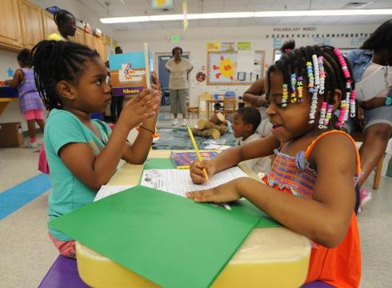
- Democratic Learning experiences that engage students, giving them voice and choice in how they learn.
- Project-Based Learning that helps students gain knowledge and skills through working for an extended period of time to investigate and respond to engaging and complex questions, problems, and challenges.
- Rich Curriculum with numerous opportunities for students to learn through engaging with the arts, history, social studies, the sciences, engineering, practical living, and vocational exploration with career pathways.
- Engaging and Authentic learning experiences that are individualized and help the whole-child learn and grow into responsible, empathetic, and compassionate community members.
- Entrepreneurial Experiences that are community-based and community-supported that let students explore the possibilities their talents and interests provide them and find ways to develop them into a life-long career or vocation.
- Opportunities for Creativity, Critical Thinking, and Collaboration so that they can be prepared for their future.
- A VARIETY of ASSESSMENTS, such as projects, performance events, and presentations, that offer ways for students to really demonstrate what they know, what they can do, and who they are.
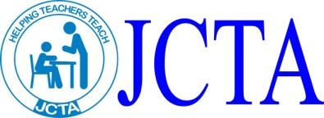
Public Educators making a difference.

